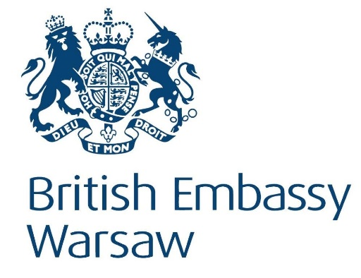

**Invitation to a Business Event at the British Embassy, 26 March**

As Britain prepares to exit the European Union, securing a deal remains the UK Government’s top priority. However the Government is also continuing with preparations for a No Deal Brexit preparations to ensure we areprepared for every eventuality.

As part of those preparations, the British Embassy in Warsaw would like to invite representatives from business and industry, which export and transport goods to the UK, to an event on 26 March about preparations for a No Deal Brexit.

This will be a chance to speak directly with UK officials working on the key issues in relation to the trading with the UK via Dover and Eurotunnel, to learn about what to expect at the UK border, and to share your own concerns.

RSVP to [Michal.Sobczyk@fco.gov.uk](mailto:Michal.Sobczyk@fco.gov.uk) by Weds 20 March to secure your attendance.

An outline DRAFT programme for the event:

09:30 registration and coffee

10:00 welcome – Ambassador Jonathan Knott

10:30 presentations from UK officials on customs, tariffs, transit and road transport, agriculture and food products, and trader readiness (including Q&A)

12:15 Lunch and market place

The event will end around 14:00